**Practical 1**

**Aim:** Communication Skills

**I. Introduction:**

Communication skills are key tools that help people share information, ideas, and emotions well. In personal relationships, school, or work good communication skills can really improve how we interact and get better results. These skills cover both talking and non-talking ways to communicate, like speaking, listening, writing, and body language.

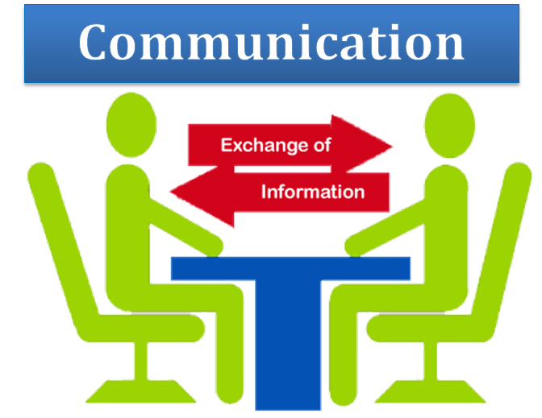

**Communication**

**1. Importance of Communication:**

* **Building Relationships:** Effective communication is the foundation of all relationships, whether personal or professional. It fosters trust, understanding, and cooperation between individuals.
* **Enhancing Teamwork:** In workplaces, strong communication skills are crucial for collaboration. They ensure that team members are on the same page, minimizing misunderstandings and conflicts.
* **Problem-Solving:** Clear communication helps in identifying issues and collaboratively finding solutions. It allows for the sharing of ideas and feedback, which is essential in decision-making processes.
* **Career Advancement:** Professionals with excellent communication skills are often more successful in their careers. They can articulate their ideas clearly, persuade others, and effectively negotiate, making them valuable assets to any organization.

**2. Elements of Communication:**

Communication is a complex process that involves several key elements, each playing a crucial role in ensuring that the message is effectively conveyed and understood. These elements work together to facilitate the exchange of information between the sender and the receiver.

* **Sender:** The person who initiates the communication, conveying an idea or message.
* **Message:** The content or information the sender wants to share.
* **Encoding:** The process of converting the message into a form (words, symbols, gestures) that can be transmitted.

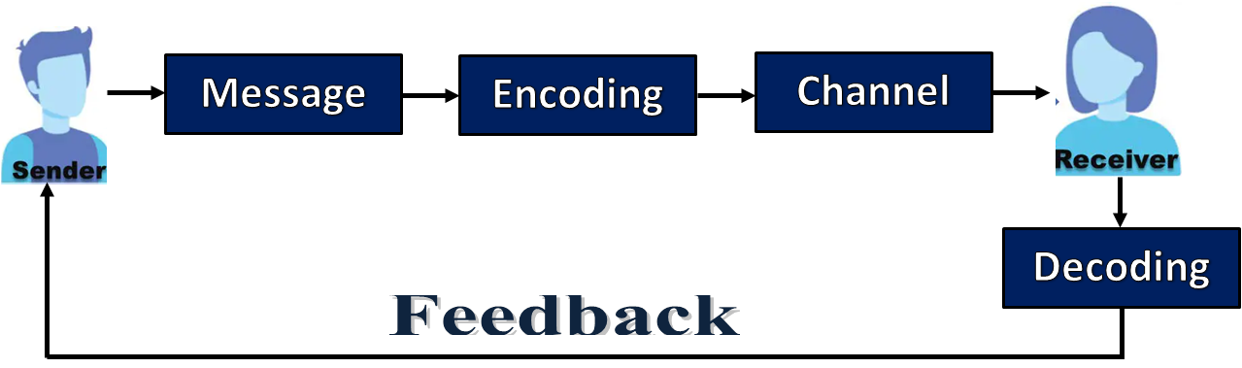

Elements of Communication

* **Channel:** The medium through which the message is sent (e.g., spoken words, emails, body language).
* **Receiver:** The person who receives and interprets the message.
* **Decoding:** The process by which the receiver interprets the sender's message.
* **Feedback:** The receiver’s response to the message, which helps the sender know if the message was understood correctly.

**3. Factors Affecting Perspective in Communication:**

Perspective in communication is influenced by a variety of factors that shape how individuals perceive, interpret, and respond to messages.

* **Cultural Background:** Different cultures have varying communication styles, values, and norms, which can influence how messages are perceived and interpreted.
* **Personal Experiences:** Past experiences shape an individual's perspective, affecting how they understand and respond to communication.
* **Emotions:** Current emotional states (e.g., happiness, anger, stress) can color how messages are interpreted, potentially leading to miscommunication.
* **Language and Vocabulary:** Differences in language proficiency or use of jargon can create barriers to understanding, impacting the receiver's perspective.
* **Education and Knowledge:** A person’s level of education and familiarity with the subject matter can influence how they interpret information.
* **Social and Economic Status:** Social standing and economic background can shape views and interpretations, as individuals may have different priorities and concerns.
* **Psychological Filters:** Individual biases, stereotypes, and mental attitudes can distort the interpretation of messages, leading to misunderstandings.
* **Context:** The situation in which communication occurs, including the environment, timing, and relationship between communicators, can heavily influence perspective.
* **Perceptual Filters:** How a person sees themselves and others can affect their interpretation of messages, leading to selective perception based on personal beliefs or attitudes.
* **Media and Technology:** The medium through which a message is delivered (e.g., text, video, face-to-face) can influence how it is received and understood.

**4. Effective Communication:**

Effective communication is the process of delivering clear, concise, and meaningful information that is accurately understood by the receiver. It goes beyond just exchanging words; it involves ensuring that the message is conveyed in a way that leads to mutual understanding and minimizes the risk of misunderstandings. Here are key aspects of effective communication:

* **Clarity:** Convey clear and concise messages.
* **Active Listening:** Engage fully and provide feedback.
* **Non-Verbal Cues:** Use appropriate body language and tone.
* **Empathy:** Understand and consider the receiver's perspective.
* **Feedback:** Encourage questions and clarify doubts.
* **Adaptability:** Tailor communication to fit the audience and context.

**II. Conversation:**



A back-and-forth chat between two or more people where they share ideas, thoughts, or facts. It's a conversation that involves talking, hearing, and answering each other. 1. How to a Conversation? To foster a meaningful and engaging conversation, it's important to approach the interaction with clarity and attentiveness. Effective communication involves not just speaking your thoughts but also actively listening and responding to the other person's contributions. By following these key steps, you can ensure that the conversation remains productive and enjoyable for all parties involved.

* **Start with a Greeting:** Open with a friendly greeting to set a positive tone.
* **Choose a Topic:** Select a relevant or interesting topic to discuss, based on the context and the interests of the participants.
* **Engage Actively:** Show genuine interest in the other person’s contributions by listening attentively and asking follow-up questions.
* **Use Clear Language:** Communicate your thoughts clearly and concisely to avoid misunderstandings.
* **Be Mindful of Non-Verbal Cues:** Pay attention to body language, eye contact, and tone of voice to enhance the interaction.
* **Give and Receive Feedback:** Offer constructive feedback and be open to receiving it to keep the conversation productive.
* **Stay on Topic:** Keep the discussion focused on the main subject to maintain relevance and coherence.
* **Be Respectful:** Respect differing opinions and avoid interrupting or dominating the conversation.
* **Summarize Key Points:** Recap important points to ensure mutual understanding and reinforce the main ideas.
* **Close Politely:** End the conversation on a positive note, expressing appreciation for the discussion and, if appropriate, suggesting a follow-up.

**2. Tips to improve your style:**

Knowing yourself, through investment in versatile and well-fitting apparel, is very fundamental to personal style enhancement. You will refresh your look by experimenting with trends and accessories, but in a way that will still stampede a unique signature style. Confidence in what you wear always does wonders for your overall appearance.

* **Know Your Preferences:** Identify what styles you are drawn to and what suits your personality and body type.
* **Invest in Basics:** Build a wardrobe with high-quality, versatile basics that can be mixed and matched.
* **Experiment with Trends:** Incorporate current trends in moderation to keep your style fresh without overshadowing your personal preferences.
* **Pay Attention to Fit:** Ensure that your clothes fit well and complement your body shape. Tailoring can make a significant difference.
* **Use Accessories:** Enhance your outfits with accessories like scarves, watches, or jewelry to add a personal touch.
* **Develop a Signature Look:** Find a unique element that defines your style, whether it's a specific color, pattern, or accessory.
* **Keep It Simple:** Avoid overloading outfits with too many elements. Sometimes, less is more.
* **Stay Updated:** Follow fashion blogs, magazines, or social media influencers for inspiration and updates on current trends.
* **Practice Good Grooming:** Maintain personal grooming and hygiene to complement your style and create a polished look.
* **Be Confident:** Wear what makes you feel good and confident. Confidence is the best accessory for any outfit.

**3. How to Respond Relatively and Appropriately:**

To respond effectively in a conversation, ensure your replies are relevant and considerate of the context and the other person's perspective. Here’s how:

* **Understand the Context:** Before responding, fully grasp the topic and the nuances of the discussion to provide a relevant reply.
* **Listen Actively:** Pay close attention to the speaker’s message, which will help you craft a thoughtful and appropriate response.
* **Acknowledge and Reflect:** Show that you’ve heard and understood their point by acknowledging their comments and reflecting on them before replying.
* **Stay On-Topic:** Keep your response focused on the current topic of discussion to maintain relevance and coherence. ➢ Be Respectful: Offer your response in a respectful manner, considering the other person's feelings and perspectives.
* **Use Clear Language:** Express your thoughts clearly and concisely to avoid misunderstandings and ensure your message is easily understood.

**Practical 2**

**Aim:** Presentation Skills

**Introduction:**

Presentation skills are essential for effectively conveying information, ideas, or proposals to an audience. Mastering these skills can enhance your ability to communicate clearly, engage your audience, and achieve your objectives. Here’s a brief overview of key aspects of presentation skills:

* **Planning and Organization:** Effective presentations start with careful –planning. Organize your content logically with a clear introduction, main points, and conclusion.
* **Visual Aids:** Use visual aids like slides, charts, and images to support and enhance your message, making it more engaging and easier to understand.
* **Public Speaking:** Develop strong public speaking skills, including clear articulation, proper pacing, and confident body language to convey your message effectively.
* **Audience Engagement:** Interact with your audience through questions, discussions, and feedback to keep them involved and interested in your presentation.
* **Practice and Rehearsal:** Regular practice and rehearsal help refine your delivery, improve your timing, and increase your confidence.
* **Handling Questions:** Be prepared to handle questions from the audience professionally, providing clear and concise answers to reinforce your credibility.

**Types of Presentation:**

Knowing about the different kinds of presentations can help you adjust your method to suit what your audience needs. Each kind has a different goal, like giving information, convincing people, or making them enjoy and stay interested. Picking the right kind for what you want to achieve makes sure your message comes across clearly and well.

* **Informative:** Educates the audience on a specific topic. Examples: Lectures, tutorials.
* **Persuasive:** Convinces the audience to adopt a viewpoint or take action. Examples: Sales pitches, proposals.
* **Inspirational:** Motivates or inspires the audience. Examples: Keynote speeches, motivational talks.
* **Demonstrative:** Shows how something works or how to perform a task. Examples: Product demos, cooking shows.
* **Entertaining:** Amuses or entertains while delivering a message. Examples: Stand up comedy, performance art.
* **Briefing:** Provides a concise update or summary. Examples: Status updates, project summaries.
* **Interactive:** Engages the audience with interactive elements. Examples: Workshops, Q&A sessions.

**Points of Delivering the presentation to the audience:**

To be able to deliver an effective presentation to one's audience, it needs to start right at the very beginning with engaging them and keeping their interest flowing until the very end. This includes developing an attention-grabbing opening, clearly organizing one's content, and using visual aids to support the message being given. The key components to a good presentation are keeping the audience interested and staying on time.

* **Know Your Audience:** Tailor your content to the interests, knowledge level, and needs of your audience.
* **Start Strong:** Begin with a compelling opening to capture attention and set the stage for your presentation.
* **Organize Clearly:** Structure your presentation with a clear introduction, main points, and conclusion.
* **Engage with Visuals:** Use slides, charts, or videos to support your message and maintain interest.
* **Practice Delivery:** Rehearse your presentation to ensure smooth delivery and familiarity with the content.
* **Maintain Eye Contact:** Connect with your audience by making eye contact to keep them engaged.
* **Use a Clear Voice:** Speak clearly and at an appropriate volume to ensure everyone can hear and understand you.
* **Encourage Interaction:** Invite questions and feedback to foster engagement and address audience concerns.
* **Manage Time:** Keep track of time to ensure you cover all key points without overrunning.
* **Close Effectively:** Summarize the main points and end with a strong conclusion or call to action

**Practical 3**

**Aim:** Modes and Types of Communication

**Introduction:**

Communication is a fundamental aspect of human interaction, facilitating the exchange of information, ideas, and emotions. It is essential for establishing relationships, understanding others, and effectively conveying messages. Communication can occur through various modes and types, each with unique characteristics and applications. Understanding these modes and types helps us choose the most effective way to communicate in different contexts.

**I. Verbal Communication**

Verbal communication involves the use of words to share information with others. It can occur through spoken or written language and is a primary mode of human interaction.

**a) Oral Communication**

* **Definition:** Spoken communication, such as conversations, phone calls, speeches, and meetings.
* **Examples:** Face-to-face talks, video calls, public speaking.
* **Characteristics:** Immediate feedback, personal, can express emotions, and can be formal or informal.

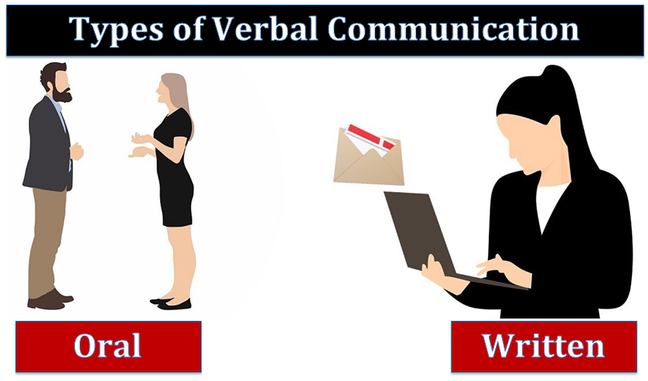

**Types of Verbal Communication**

**b) Written Communication**

* **Definition:** Communication through written words.
* **Examples:** Emails, reports, letters, text messages.
* 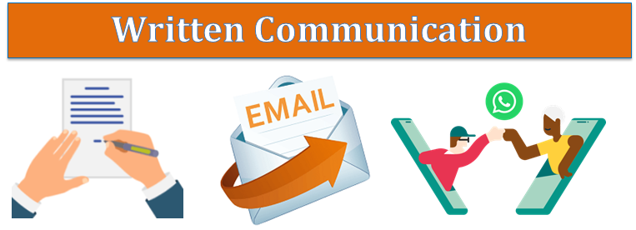**Characteristics:** Provides a permanent record, allows for careful wording, usually more formal, can reach a large audience.

**Written Communication**

**c) Visual and Audio-Visual Communication**

* **Definition:** Combines spoken or written words with visual elements.
* **Examples:** Presentations, videos, infographics, webinars.
* **Characteristics:** Engages multiple senses, useful for complex ideas, more memorable, effective for large audiences.

**d) Silence**

* **Definition:** Non-verbal communication using the absence of words.
* **Examples:** Pauses in conversation, moments of reflection.
* **Characteristics:** Can convey emotions or messages, used for emphasis, interpretation depends on context.

**II. Non-Verbal Communication**

Non-verbal communication involves conveying messages without spoken words. It relies on body language, facial expressions, posture, gestures, touch, and space to communicate emotions and intentions.

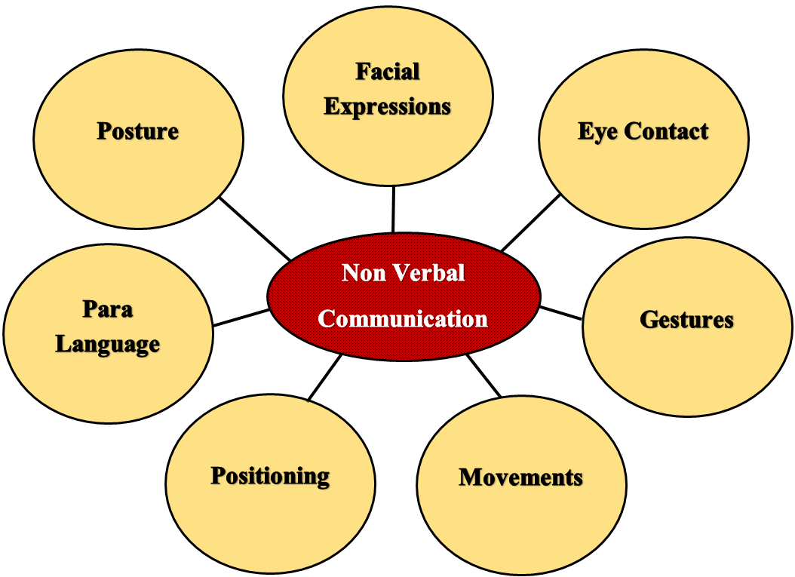

**Non Verbal Communication**

**a) Body Language (Kinesics)**

* **Definition:** The use of body movements to convey messages.
* **Examples:** Eye contact, facial expressions, arm movements, and overall demeanour.
* **Characteristics:** Can indicate confidence, interest, aggression, or openness.

**b) Facial Expressions**

* **Definition:** Expressions on the face that convey emotions.
* **Examples:** Smiling, frowning, raising eyebrows.
* **Characteristics:** Universally recognized and powerful in expressing emotions like happiness, anger, or surprise.

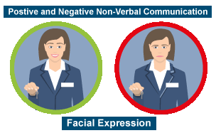 **Facial Expression**

**c) Posture**

* **Definition:** The way a person stands or sits.
* **Examples:** Slouching, standing tall, crossing arms.
* **Characteristics:** Indicates confidence, openness, defensiveness, or submissiveness.

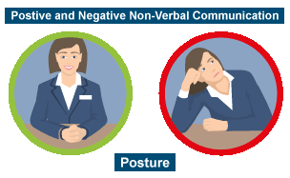

**Posture**

**d) Gestures**

* **Definition:** Movements of the hands and arms to express ideas or emotions.
* **Examples:** Waving, thumbs up, pointing.
* **Characteristics:** Can reinforce spoken words, indicate direction, or express feelings.

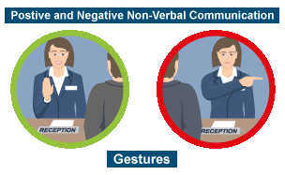

**Gestures**

**e) Touch (Haptics)**

* **Definition:** Communication through physical contact.
* **Examples:** Handshakes, hugs, pats on the back.
* **Characteristics:** Can convey support, affection, or dominance; varies greatly by culture.

**f) Proxemics**

* **Definition:** The use of physical space in communication.
* **Examples:** Personal space, physical distance in conversations.
* **Characteristics:** Indicates intimacy, aggression, or formality; influenced by cultural norms.

**III. Aural Communication**

Aural communication involves the transmission of information through listening and hearing. It focuses on sounds, including spoken words, music, and other auditory signals, to convey messages and emotions.

**Features of Aural Communication**

* **Sound-Based**: Relies on sounds, including speech, music, alarms, and other audio cues to convey information.
* **Requires Listening Skills**: Effective aural communication depends on active listening, which involves fully concentrating, understanding, responding, and remembering what is being heard.
* **Immediate Feedback**: In face-to-face or real-time conversations, aural communication allows for immediate responses and feedback, which helps clarify and confirm understanding.
* **Conveys Emotions**: Tone, pitch, volume, and pace of speech can express emotions and attitudes, such as happiness, anger, excitement, or sarcasm.
* **Enhances Memory Retention**: Listening to information can enhance memory retention, especially when combined with verbal and non-verbal cues.
* **Accessibility**: Aural communication is accessible to individuals who are visually impaired and relies less on written or visual cues.
* **Cultural and Contextual Influences**: The effectiveness and interpretation of aural communication can be influenced by cultural norms and context, including accents, dialects, and cultural expressions.

**IV. Difference between Verbal, Nonverbal and Aural communication**

|  |  |  |  |
| --- | --- | --- | --- |
| **Aspect** | **Verbal Communication** | **Non-Verbal Communication** | **Aural Communication** |
| **Definition** | Use of words (spoken or written) to convey messages. | Use of body language, facial expressions, gestures, and space to communicate. | Involves listening and hearing sounds, such as speech or music, to receive messages. |
| **Medium** | Spoken (oral) or written language. | Visual cues like body movements, facial expressions, gestures, and touch. | Auditory cues like speech, music, tone, and volume. |
| **Examples** | Conversations, speeches, emails, reports, texts. | Eye contact, hand gestures, posture, facial expressions, personal space. | Listening to a lecture, music, alarms, or spoken words. |
| **Feedback** | Can be immediate (in oral communication) or delayed (in written communication). | Often immediate and visual; feedback can be subtle and indirect. | Often immediate, especially in face-to-face interactions, but depends on the context. |
| **Emotional Conveyance** | Through words, tone, and choice of language. | Through body language, facial expressions, touch, and proximity. | Through tone, pitch, volume, and pace of sound. |
| **Clarity of Message** | Can be very clear and explicit when well-structured. | Can be ambiguous; relies on interpretation of non-verbal cues. | Can vary; depends on the clarity of sound and listener’s attentiveness. |
| **Cultural Sensitivity** | Language and phrases can vary significantly by culture. | Heavily influenced by cultural norms and practices. | Accents, dialects, and sound interpretations can vary culturally. |
| **Skills Required** | Speaking, writing, reading, and comprehension. | Observational skills, interpretation of body language and facial cues. | Active listening and auditory discrimination skills. |
| **Use in Communication** | To convey specific information, ideas, and instructions. | To express emotions, reinforce or contradict verbal messages, and regulate interactions. | To interpret spoken language, understand context, and receive auditory information. |

**Practical 4**

**Aim:** Interpersonal Communication 1

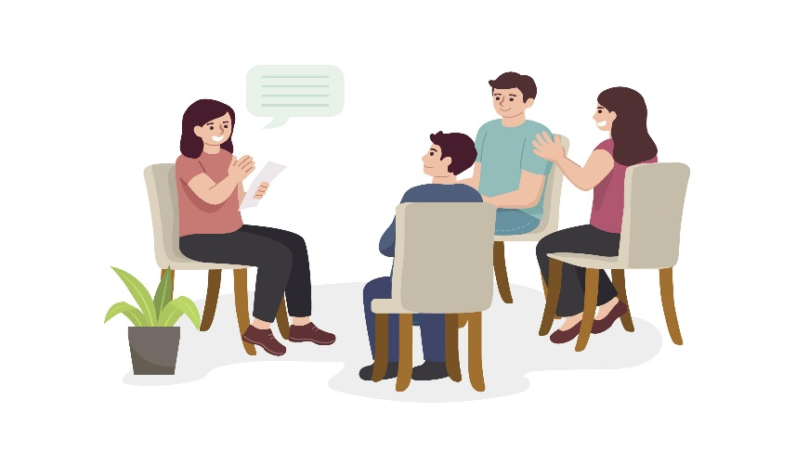**Introduction:**

**I. Interpersonal communication** involves the exchange of information, feelings, and meanings between individuals through verbal and non-verbal methods.

**II. Interpersonal individual and group communication** involves the exchange of information, ideas, and emotions between individuals, either one-on-one or within a group. It requires adapting communication styles to maintain effective understanding and collaboration, whether in personal interactions or group discussions.

**III. Cultural factors in interpersonal communication** affect how people communicate based on their language, values, gestures, and customs. These differences can influence understanding, making it important to respect and adapt to various cultural norms for effective communication.

**IV. What is the purpose of communication to an individual?**

* The purpose of communication for an individual is to share information, express thoughts and emotions, build relationships, and understand others. It helps in personal growth, social interaction, and achieving goals.

**V. Why is it important to communicate with individuals?**

* It is important to communicate with individuals to foster connections, exchange ideas, resolve conflicts, and promote mutual understanding. Effective communication enhances relationships and collaboration.

**VI. What are the benefits of effective communication to an individual?**

* Effective communication improves clarity, reduces misunderstandings, strengthens relationships, increases confidence, and helps in problem-solving. It also promotes personal and professional success.

**VII. What are interpersonal communications?**

* Interpersonal communications are direct, face-to-face interactions between two or more people, involving verbal and non-verbal exchanges to share information, ideas, or feelings.

**VIII. What are the 9 stages of interpersonal communication?**

* While stages may vary, common stages include:
  1. Initiating
  2. Experimenting
  3. Intensifying
  4. Integrating
  5. Bonding
  6. Differentiating
  7. Circumscribing
  8. Stagnating
  9. Terminating

**IX. What are the five rules of interpersonal communication?**

* Common rules include:
  1. Listen actively.
  2. Be clear and concise.
  3. Show empathy.
  4. Maintain appropriate body language.
  5. Provide constructive feedback.

**X. Difference between Interpersonal Individual & Group Communication?**

* **Interpersonal Individual Communication** is a one-on-one interaction between two people, focusing on personal exchanges of thoughts and feelings.
* **Group Communication** involves interactions among multiple people, where the focus is on sharing information, discussing ideas, and making decisions as a group.

**XI. What is culture as communication?**

* Culture can be understood as a system of communication through which people express their values, norms, and beliefs. It shapes how individuals behave, communicate, and interact within a society.

**XII. Why is culture important? What are the major characteristics of culture?**

* Culture is important because it defines the social framework within which people communicate and interact. Major characteristics include:
  1. **Language:** A tool for conveying ideas and emotions.
  2. **Beliefs and Values:** Guiding principles and standards of behavior.
  3. **Customs and Traditions:** Social practices that dictate how people interact.
  4. **Symbols and Norms:** Shared meanings and expectations within a culture.

**XIII. What is cultural content of communication?**

* Cultural content refers to the specific values, beliefs, and practices that are communicated within a particular culture. It influences how messages are interpreted based on cultural norms.

**XIV. How does culture impact communication?**

* Culture impacts communication by shaping language, non-verbal cues, and social norms. Differences in cultural backgrounds can lead to misunderstandings, but understanding cultural contexts improves communication and reduces conflicts.

**Conclusion:**

Cultural factors play a crucial role in interpersonal communication. By understanding and respecting cultural differences, we can communicate more effectively, reduce misunderstandings, and build better relationships in both individual and group settings.

**Practical 5**

**Aim:** Interpersonal Communication 2

**Introduction:**



Interpersonal communication involves the exchange of information, feelings, and meanings between individuals through verbal and non-verbal methods.

**I. Emotional in Interpersonal Communication** involves how emotions affect interactions, shaping tone, body language, and clarity. Managing emotions well improves understanding, strengthens relationships, and prevents misunderstandings.

**II. Interpersonal Individual and Group Communication** is about one-on-one communication and communication within groups. Individual is personal, while group requires coordination and clarity for effective interaction.

**III. Cultural Factors in Interpersonal Communication** influence how people interpret and convey messages. Differences in language, values, beliefs, and social norms can impact communication styles, body language, and understanding. Being aware of cultural diversity helps in avoiding miscommunication and fosters respect in interactions across different cultural backgrounds.

**IV. What are 5 steps for expressing emotions effectively in interpersonal communication?**

* The 5 steps for expressing emotions effectively in interpersonal communication are:

1. **Identify the Emotion**: Clearly recognize and label the emotion you're feeling.
2. **Assess the Intensity**: Understand the strength of the emotion before expressing it.
3. **Choose the Right Time and Place**: Ensure the setting is appropriate for expressing your emotions.
4. **Use "I" Statements**: Frame your feelings using "I" to take responsibility (e.g., "I feel upset" instead of "You made me upset").
5. **Be Clear and Direct**: Express your emotions in a straightforward and concise way without blaming or attacking the other person.

**V. Why is emotion important in communication?**

* Emotions are important because they help convey the true intent and feelings behind the message, fostering a deeper connection, understanding, and empathy between communicators.

**VI. How to control emotions? What are the steps of managing emotions?**

* To control emotions: Recognize the emotion, pause before reacting, focus on your thoughts, and reframe the situation positively.
* Steps of managing emotions:
  1. Identify the emotion.
  2. Understand the trigger.
  3. Express it constructively.
  4. Regulate through self-awareness.

**VII. What are the pillars of emotion?**

* The pillars of emotion include:
  1. Self-awareness: Understanding your emotions.
  2. Self-regulation: Managing your emotions effectively.
  3. Motivation: Harnessing emotions for positive outcomes.
  4. Empathy: Understanding the emotions of others.
  5. Social skills: Navigating emotions in relationships.

**VIII. What are the effects of social skills?**

* Strong social skills lead to better interpersonal relationships, improved teamwork, greater leadership abilities, and more effective conflict resolution.

**IX. How important are social skills?**

* Social skills are crucial for effective communication, collaboration, and building relationships. They enable individuals to navigate social situations, resolve conflicts, and maintain personal and professional connections.

**X. How to improve social skills in students? What are the strengths of social skills training?**

* Social skills can be improved by practicing active listening, engaging in group activities, participating in role-playing exercises, and receiving feedback.
* The strengths of social skills training include enhanced communication abilities, better emotional regulation, improved conflict resolution, and increased empathy.

**XI. Difference between Interpersonal and Intrapersonal Communication?**

* **Interpersonal communication** is the exchange of information between two or more people, focusing on interaction with others.
* **Intrapersonal communication** is communication with oneself, involving internal thoughts, self-reflection, and self-dialogue.

**XII. What is emotional intelligence? How to improve emotional intelligence?**

* Emotional intelligence is the ability to recognize, understand, and manage one's own emotions, as well as those of others.
* To improve emotional intelligence:
  1. Increase self-awareness.
  2. Practice empathy.
  3. Learn to manage stress.
  4. Strengthen social skills.

**XIII. Why is empathy important in communication?**

* Empathy allows individuals to understand and share the feelings of others, which helps build trust, reduce misunderstandings, and enhance relationships.

**XIV. How to communicate with people who have different tolerance for change?**

* Communicate with empathy, acknowledge their concerns, provide clear reasons for change, and offer support. It’s important to be patient, listen actively, and involve them in the process to ease their apprehension.

**Conclusion:**

Understanding and managing emotions effectively, along with honing social skills, are key to successful interpersonal communication. By improving emotional intelligence, empathy, and recognizing the differences in tolerance for change, individuals can enhance their communication skills both in personal and professional settings. These skills are crucial for fostering better relationships and navigating diverse social environments.

**Practical 6**

**Aim:** Developing Key baits: Creativity, critical thinking and problem solving.

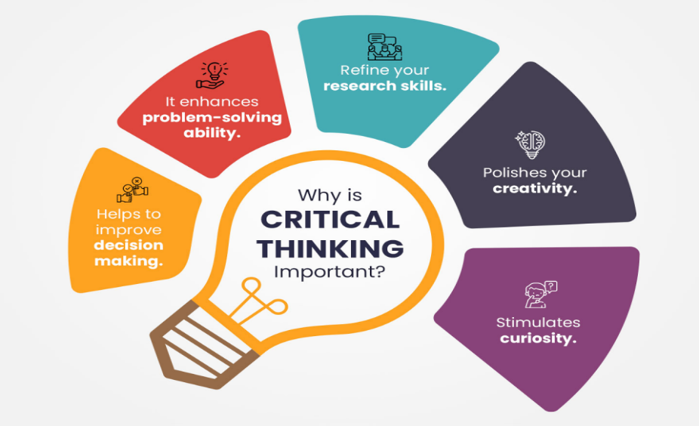**Introduction:**

Creativity, critical thinking, and problem-solving are essential skills that enhance innovative thinking, logical evaluation, and effective communication. These abilities help in tackling challenges and expressing ideas clearly.

**I. What is creativity communication? What are the 4 pillars of creativity?**

* Creativity communication involves expressing ideas in an innovative and effective way. The four pillars of creativity are fluency, flexibility, originality, and elaboration.

**II. What are the 7Cs of effective communication (creativity)?**

* The 7Cs are: clarity, conciseness, concreteness, correctness, coherence, completeness, and courtesy. These principles ensure effective and creative communication.

**III. What are the critical thinking examples?**

* Examples include analysing facts to form a judgment, questioning assumptions, and evaluating arguments with logic and reason.

**IV. What are the qualities of a critical thinker in communication?**

* A critical thinker is analytical, open-minded, curious, skeptical, and able to reflect on different viewpoints before making decisions.

**V. What are the communication styles in critical thinking?**

* The main communication styles are assertive, aggressive, passive, and passive-aggressive, each impacting how information is processed and conveyed during critical thinking.

**VI. Why is communication important for problem-solving?**

* Communication allows individuals to share ideas, collaborate, and ensure that solutions are understood and effectively implemented.

**VII. How to implement problem-solving skills & why?**

* Problem-solving skills can be implemented by identifying the problem, brainstorming solutions, evaluating options, and acting on the best choice. These skills are vital for overcoming obstacles efficiently.

**VIII. How to solve the right problems? What is the nature of problem-solving?**

* Solving the right problem involves properly identifying the core issue. Problem-solving requires critical thinking, creativity, and effective decision-making.

**Conclusion:**

Mastering creativity, critical thinking, and problem-solving empowers individuals to approach challenges with a well-rounded perspective. These skills are essential in identifying the right problems, crafting innovative solutions, and communicating ideas effectively to achieve success in both personal and professional settings.

**Practical 7**

**Aim:** Motivation, Persuasion, Negotiation and Leadership.

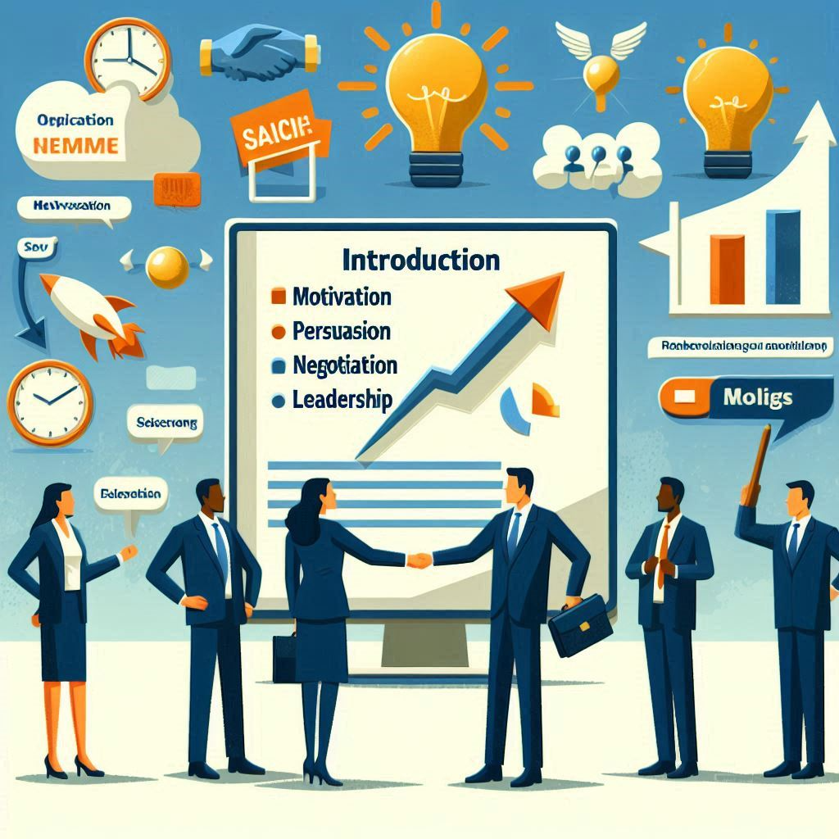**Introduction:**

**Introduction**

**Motivation** is the driving force behind individuals' actions, fueled by internal desires or external rewards. **Persuasion** involves influencing others' attitudes or behaviors through effective communication, while **Negotiation** is the process of reaching a mutual agreement by addressing conflicting interests. **Leadership** integrates these skills to inspire, guide, and influence teams toward achieving common goals.

**I. Motivation:**



**Motivation**

**Concept**

Motivation is the internal or external driving force that stimulates individuals to take action, achieve goals, and fulfil needs. It directs behaviour towards a specific outcome, whether it's personal satisfaction or external rewards.

**Nature and Role of Motivation**

* **Nature:** Motivation can be intrinsic (coming from within, like personal growth) or extrinsic (from external factors, like rewards or recognition).
* **Role:** Motivation plays a key role in enhancing performance, improving productivity, and driving individuals toward achieving personal and organizational goals.

**Process of Motivation**

1. **Need Identification**: A desire or deficiency is recognized (e.g., need for achievement).
2. **Goal Setting**: The individual sets a specific goal to satisfy the need.
3. **Action**: Effort is directed toward achieving the goal.
4. **Feedback**: Performance is reviewed, and adjustments may be made.
5. **Satisfaction/Reward**: Once the goal is achieved, satisfaction or rewards reinforce the behaviour.

**Types of Motivation**

1. **Intrinsic Motivation**: Driven by internal rewards such as personal satisfaction, passion, or interest.
   * Example: A writer working on a book because they love storytelling.
2. **Extrinsic Motivation**: Driven by external factors such as money, recognition, or promotions.
   * Example: An employee working overtime for a bonus.
3. **Positive Motivation**: Motivating through rewards and positive reinforcement.
   * Example: A student studying hard to win a scholarship.
4. **Negative Motivation**: Driven by fear of punishment or negative consequences.
   * Example: An employee meeting deadline to avoid a pay cut.

**Examples of Motivation**

* A student studying hard to secure admission to a prestigious university (intrinsic).
* A salesperson exceeding targets to earn a performance bonus (extrinsic).
* An athlete training relentlessly to win a championship (positive).
* A worker following rules strictly to avoid getting fired (negative).

**II. Persuasion:**

**Persuasion**

**Concept**

Persuasion is the process of influencing or convincing others to adopt a certain idea, belief, or behaviour through logical arguments, emotional appeal, or credibility. It is about guiding others to agree with your point of view without force or coercion.

**Persuasion Techniques**

1. **Reciprocity**: People feel compelled to return favours.
   * Example: Offering a free sample encourages customers to buy a product.
2. **Social Proof**: Individuals tend to follow the actions or decisions of others.
   * Example: Highlighting customer reviews to convince potential buyers.
3. **Scarcity**: Creating a sense of urgency by emphasizing limited availability.
   * Example: "Only 5 items left in stock!"
4. **Authority**: People are more likely to follow the guidance of experts or authoritative figures.
   * Example: A doctor endorsing a particular medication.
5. **Liking**: People are more easily persuaded by individuals they like or relate to.
   * Example: Using a celebrity endorsement to promote a brand.
6. **Consistency**: Encouraging small commitments that lead to larger commitments over time.
   * Example: Getting someone to agree to a minor task, making them more likely to agree to a larger request later.

**Example of Persuasion**

A salesperson using customer testimonials and limited-time offers to persuade a buyer to purchase a product. They emphasize how others have benefited from the product and offer a discount to create urgency.

**Difference Between Persuasion and Manipulation**

* **Persuasion**: Involves ethically influencing someone by presenting facts, logic, and benefits. The goal is mutual benefit, with the person being free to make their own decision.
  + Example: A teacher convincing student to study hard by showing the long-term career benefits of good grades.
* **Manipulation**: Involves deceit or hidden agendas to influence someone for personal gain, often at the expense of the other person’s well-being or choices.
  + **Example:** A person exaggerating the risks of not buying a product just to make a sale.

**Key Difference:**

Persuasion respects the other person's autonomy and is transparent, while manipulation uses deceptive tactics to control someone’s decisions.

**III. Negotiation**

**Negotiation**

**Concept**

Negotiation is the process where two or more parties engage in discussions to resolve conflicts, agree on terms, or settle differences. The goal is to reach a mutually acceptable solution through dialogue, compromise, and agreement.

**Types of Negotiation**

1. **Distributive Negotiation**: Also known as "win-lose" negotiation, this involves dividing a fixed amount of resources, where one party’s gain is another party’s loss.

**Example:** Price negotiation for a car.

1. **Integrative Negotiation**: Also called "win-win" negotiation, both parties collaborate to find a solution that satisfies the interests of all involved.

**Example:** Business partnerships where both parties benefit from the deal.

**A Strategy for Successful Negotiation**

1. **Preparation**: Research and understand your goals, the other party’s needs, and possible outcomes.
2. **Active Listening**: Pay attention to what the other side says, understanding their perspective and concerns.
3. **Finding Common Ground**: Focus on shared interests to build a foundation for agreement.
4. **Making Concessions**: Be willing to give up minor points to gain larger, more important benefits.

**Negotiating Jointly**

Negotiating jointly involves working together as a team to find a solution that benefits all parties. This approach emphasizes collaboration over competition, aiming to create value rather than claim it. The focus is on finding shared goals and building long-term relationships.

**Negotiating to Win**

This involves striving to achieve the best possible outcome for yourself or your side, while still maintaining fairness and respect. Negotiating to win doesn’t mean making the other party lose, but rather ensuring your objectives are met, sometimes through assertive tactics or better preparation.

**How Not to Negotiate?**

* **Being Rigid**: Refusing to make any compromises can lead to a breakdown in communication.
* **Ignoring the Other Party’s Needs**: Focusing solely on your own interests without considering the other side can cause resentment and failure.
* **Overpowering Tactics**: Using aggressive or manipulative strategies often backfires, damaging trust and relationships.

**What is BATNA Strategy?**

BATNA (Best Alternative to a Negotiated Agreement) refers to the best course of action you can take if negotiations fail. It’s your fallback option. Knowing your BATNA gives you leverage during negotiation, helping you avoid settling for unfavourable terms.

**Example:** If you’re negotiating a job offer, your BATNA could be accepting another job or staying at your current position.

**IV. Leadership**



**Leadership**

**Concept**

Leadership is the ability to guide, influence, and inspire individuals or groups to achieve common goals. It involves making decisions, motivating others, and fostering a sense of direction and purpose.

**Importance of Managerial Leadership**

Managerial leadership is essential for:

* **Decision-Making**: Managers provide clear direction, helping teams stay focused.
* **Motivation**: Effective leaders inspire and motivate employees to perform their best.
* **Coordination**: Leadership ensures coordination between different teams and departments.
* **Change Management**: Leaders help navigate and manage organizational changes smoothly.

**Leadership Styles**

1. **Autocratic**: The leader makes decisions independently with little input from others.

**Example:** A manager who takes complete control of all decisions.

1. **Democratic**: The leader involves team members in decision-making, encouraging participation.

**Example:** A manager who seeks input before making decisions.

1. **Laissez-Faire**: The leader gives employees the freedom to make decisions and work independently.

**Example:** A manager who allows a creative team to manage projects without interference.

1. **Transformational**: Focuses on inspiring and motivating teams to innovate and create change.

**Example:** A leader who challenges employees to grow and exceed their own expectations.

**Functions of Leadership**

1. **Setting Vision**: Defining a clear direction and future goals for the team or organization.
2. **Guiding Team Members**: Providing guidance, support, and direction to achieve objectives.
3. **Motivating and Inspiring**: Keeping employees engaged and motivated to perform at their highest potential.
4. **Building Trust and Cooperation**: Creating a positive work environment with collaboration and trust.
5. **Problem-Solving**: Addressing challenges and finding solutions for obstacles the team may face.

**Leadership Effectiveness**

Leadership effectiveness refers to how well a leader achieves desired results while maintaining a positive impact on the team. Effective leaders:

* **Inspire high performance**.
* **Foster collaboration** and team cohesion.
* **Make sound decisions** under pressure.
* **Build trust** with their teams.

**Qualities of an Effective Leader**

1. **Visionary**: An effective leader has a clear vision of what they want to achieve and can communicate this vision to inspire others.
2. **Good Communicator**: Able to express ideas clearly, listen actively, and encourage open dialogue.
3. **Empathy**: Understands and cares about the feelings and needs of others.
4. **Decisiveness**: Makes timely and firm decisions even in difficult situations.
5. **Integrity**: Maintains honesty and ethics in all interactions.
6. **Adaptability**: Adjusts strategies and approaches based on changing circumstances or challenges.
7. **Confidence**: Leads with self-assurance, instilling confidence in the team.

Effective leaders balance these qualities to achieve organizational success and maintain strong team dynamics.

**Conclusion**

Motivation, persuasion, negotiation, and leadership are essential skills for success. Motivation drives goal achievement, persuasion ethically influences decisions, negotiation resolves conflicts, and leadership guides teams toward common objectives. Together, they create a foundation for effective communication and collaboration, fostering positive outcomes in any environment.

**Practical 8**

**Aim:** Vocational Skill, Management stress and time.

**Introduction:**

**Introduction**

Vocational skills are practical abilities that equip individuals for specific trades or careers, emphasizing hands-on experience and expertise. Effective management of stress and time is crucial in today's fast-paced work environment, as it enhances productivity and well-being. Balancing these elements allows professionals to perform optimally, fostering both personal growth and organizational success.

**I. Vocational Skill:**

**Vocational Skill**

**Vocational Skill**

Vocational skills are specialized abilities and competencies required to perform specific tasks related to a particular job or trade. These skills often include technical knowledge and practical expertise necessary for success in various professions, such as carpentry, plumbing, or culinary arts.

**Vocational Qualification**

Vocational qualifications are certifications or credentials obtained through education and training programs that demonstrate an individual's competence in a specific vocational area. These qualifications are often recognized by employers and educational institutions, validating a person's skills and knowledge for a particular occupation.

**Pre-Vocational Skill**

Pre-vocational skills refer to the foundational skills and competencies that prepare individuals for vocational training or employment. These skills include basic communication, teamwork, problem-solving, and time management, essential for succeeding in a vocational environment.

**Example of Vocational Skill**

An example of a vocational skill is **welding**. This skill involves the ability to join metal parts using high heat and specialized equipment, which is essential in industries such as construction, manufacturing, and automotive repair.

**II. Stress Management:**



**Stress Management**

**Concept**

Stress management involves strategies and techniques to help individuals cope with and reduce the effects of stress. It aims to improve overall well-being by fostering resilience, enhancing coping skills, and promoting a balanced lifestyle.

**Causes of Stress**

1. **Work-Related Stress**: High workloads, tight deadlines, and job insecurity can contribute to stress.
2. **Life Changes**: Major life events such as moving, marriage, divorce, or the death of a loved one can trigger stress.
3. **Financial Issues**: Economic instability or personal financial problems often lead to increased stress levels.
4. **Health Concerns**: Chronic illnesses or sudden health issues can cause significant emotional and physical stress.
5. **Interpersonal Relationships**: Conflicts with family, friends, or colleagues can create emotional tension.

**3 C's of Stress**

1. **Commitment**: Engaging fully in tasks and responsibilities enhances motivation and a sense of purpose, which can mitigate stress.
2. **Control**: Feeling in control of one’s circumstances reduces anxiety and helps manage stress more effectively. This involves taking proactive steps to influence outcomes.
3. **Challenge**: Viewing stressors as challenges rather than threats can foster a positive mindset, promoting personal growth and resilience.

**4 A's of Stress Management**

1. **Avoid**: Identify stressors and avoid them when possible, such as saying no to excessive responsibilities or distancing from negative influences.
2. **Adapt**: Change your perspective on stressors. Develop realistic expectations and adjust your approach to challenges.
3. **Alter**: Communicate openly about your feelings and needs. Seek to change the situation by discussing issues or negotiating solutions.
4. **Accept**: Accept the things you cannot change. Focus on adapting to circumstances rather than fighting against them.

**Ways to Reduce Stress**

1. **Exercise**: Regular physical activity helps release endorphins, which improve mood and reduce stress.
2. **Mindfulness and Meditation**: Practicing mindfulness or meditation can enhance focus, promote relaxation, and decrease anxiety.
3. **Time Management**: Organizing tasks and prioritizing responsibilities can alleviate feelings of being overwhelmed.
4. **Social Support**: Connecting with friends and family provides emotional support and can help reduce feelings of isolation.
5. **Healthy Lifestyle**: Maintaining a balanced diet, getting enough sleep, and avoiding excessive caffeine and alcohol can improve resilience against stress.
6. **Hobbies and Leisure Activities**: Engaging in enjoyable activities can provide a mental break and foster relaxation.

**III. Time Management:**

**Time Management**

**Concept**

Time management refers to the process of planning and organizing how much time you allocate to specific activities. Effective time management enables individuals to complete more in a shorter period, lowers stress, and leads to career success. It involves setting goals, prioritizing tasks, and using tools to enhance productivity.

**Time Management Techniques**

1. **Prioritization**: Determine which tasks are most important and tackle them first based on urgency and significance.
2. **Time Blocking**: Allocate specific blocks of time for different activities or tasks throughout the day to minimize distractions.
3. **Pomodoro Technique**: Work for 25 minutes, then take a 5-minute break. After four cycles, take a longer break (15-30 minutes) to recharge.
4. **To-Do Lists**: Create daily or weekly lists of tasks to stay organized and focused on your objectives.

**4 Skills for Time Management**

1. **Management**: Organizing tasks and responsibilities effectively to maximize productivity and ensure deadlines are met.
2. **Avoidance**: Recognizing tasks or distractions that waste time and finding ways to minimize or eliminate them.
3. **Limits**: Setting boundaries for how much time to spend on certain activities to avoid burnout and maintain balance.
4. **Focus**: Concentrating on one task at a time to enhance efficiency and quality of work, avoiding multitasking.

**Strategies for Time Management**

1. **Set Clear Goals**: Define short-term and long-term goals to give direction to your efforts.
2. **Use a Planner**: Utilize digital or physical planners to schedule tasks and appointments, keeping track of deadlines.
3. **Break Tasks into Smaller Steps**: Divide larger projects into manageable tasks to make progress easier and less overwhelming.
4. **Review and Reflect**: Regularly assess your productivity and adjust your strategies based on what works best for you.

**How Can You Manage Your Time**

* **Create a Daily Schedule**: Outline your tasks for the day, prioritizing them based on urgency and importance.
* **Eliminate Distractions**: Identify what distracts you and create an environment that minimizes these interruptions (e.g., turning off notifications).
* **Practice Saying No**: Avoid overcommitting by knowing your limits and politely declining additional tasks or responsibilities that interfere with your priorities.
* **Set Time Limits**: Assign specific time limits for tasks to encourage efficiency and focus.

**Conclusion**

Vocational skills enhance employability and career satisfaction, while effective stress management promotes resilience and well-being. Mastering time management allows individuals to prioritize tasks and maximize productivity. Together, these elements foster personal growth and improve job performance, leading to a balanced and fulfilling life.